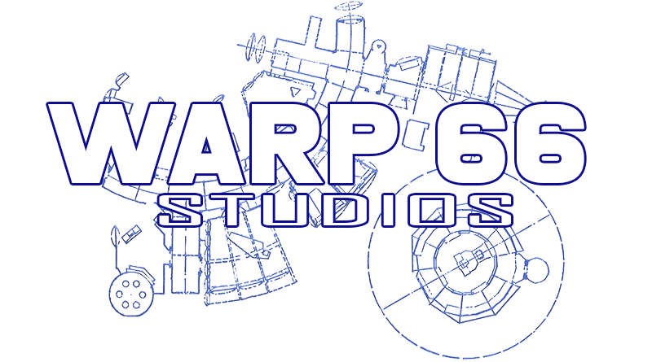

ACTOR INFORMATION & AUDITION FORM

Production Casting Submission
Production Title: “TREMBLING GROUND”
Production Company: WARP 66 Studios
Director/Producer: Dan R. Reynolds
Date Submitted:
PERSONAL INFORMATION
Full Legal Name: ____________________________________________
Stage Name (if applicable): _________________________________
Date of Birth: ______________________________________________
Age Range You Can Play: ____________________________________
Height: ___________________ Weight: ___________________
Shirt size ____________________ Pant size ____________________
Shoe size _______ Hair Color: _______________ Eye Color: ________________
Phone Number: ______________________________________________
Email Address: _____________________________________________
Home Address: ______________________________________________

City/State/Zip: ____________________________________________

EMERGENCY CONTACT
Name: _______________________________________________________
Relationship: _______________________________________________
Phone Number: ______________________________________________

ACTING EXPERIENCE

Previous Film / Television Experience
Production Title | Role Played | Director/Company | Year

Theater Experience
Production | Role | Company | Year

Special Skills
(Check all that apply)
☐ Singing
☐ Dancing
☐ Stage Combat
☐ Firearms Training
☐ Horseback Riding
☐ Martial Arts
☐ Improvisation
☐ Voice Acting
☐ Teleprompter Experience
☐ Stunt Experience
☐ Musical Instrument(s)
☐ Dialects / Accents
☐ Other: _______________________________________

AVAILABILITY
Are you available for rehearsals?
☐ Yes ☐ No
Are you available for filming dates as scheduled?
☐ Yes ☐ No
Do you have reliable transportation?
☐ Yes ☐ No
Are you willing to travel for filming?
☐ Yes ☐ No

MEDIA MATERIALS INCLUDED
☐ Headshot
☐ Resume
☐ Demo Reel
☐ Acting Reel Link
☐ Social Media Links
☐ References
Website or Reel Link: _______________________________________

SOCIAL MEDIA / PUBLIC PROFILE
Facebook: _________________________________________________
Instagram: ________________________________________________
TikTok: ____________________________________________________
YouTube: ___________________________________________________

HEALTH / PHYSICAL LIMITATIONS
Please list any medical conditions, allergies, or physical limitations production staff should be aware of:

CRIMINAL BACKGROUND DISCLOSURE
Have you ever been convicted of a felony?
☐ Yes ☐ No
If yes, explain: _______________________________________________

RELEASE & CONSENT
I certify that the information provided on this form is accurate to the best of my knowledge. I understand that submission of this form does not guarantee casting or employment in any production.
I authorize the production company to use submitted photos, video auditions, and related promotional materials for casting consideration and production purposes.
Signature: _________________________________________________
Printed Name: ______________________________________________
Date: ______________________________________________________

PRODUCTION OFFICE USE ONLY
Date Received: _____________________________________________
Role Considered For: _______________________________________
Audition Date: _____________________________________________
Callback Requested: ☐ Yes ☐ No
Casting Notes:

